Conversation Log

Below are some screenshots and annotation of the conversation between the chatbot and the user:

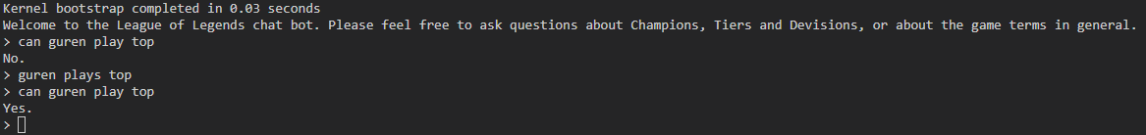Here you can see the user asking if a hero plays in a certain ‘lane’ (position) to which the bot answered with no but after it is told that that specific hero plays in that lane, it learns that and adds it to the data (folval), so when the user asks the same question again, it answers by replying ‘yes’. After the program ends, it will read the data onto a textfile so when you run it again, it will load that file in so the user doesn’t need to tell the bot about a certain hero twice as you can see below.

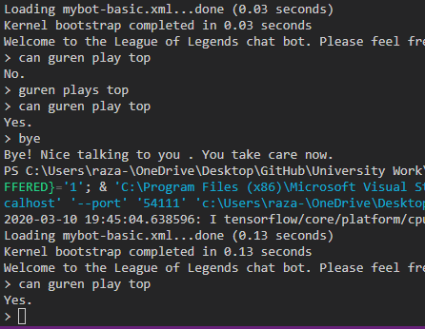

The bot also has error handling implemented. So if the users types in a champion or a lane which does not exist, it will not crash but respond by telling them they don’t exist as shown below.

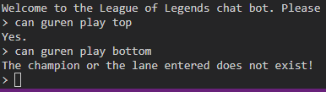

The bot also is able to tell the user if a champion plays in more than one positions or they can ask what lane (position/role) a certain champion plays, as shown below.

